Introduction to Programming II project log

Project title: | Coursework – Data Visualisation
Topic: | Week 19 and 20: Usability tests
What progress have you made on this topic?
Stability test: I went through all data visualisations to check for consistent performance.

- Tech Diversity: Race

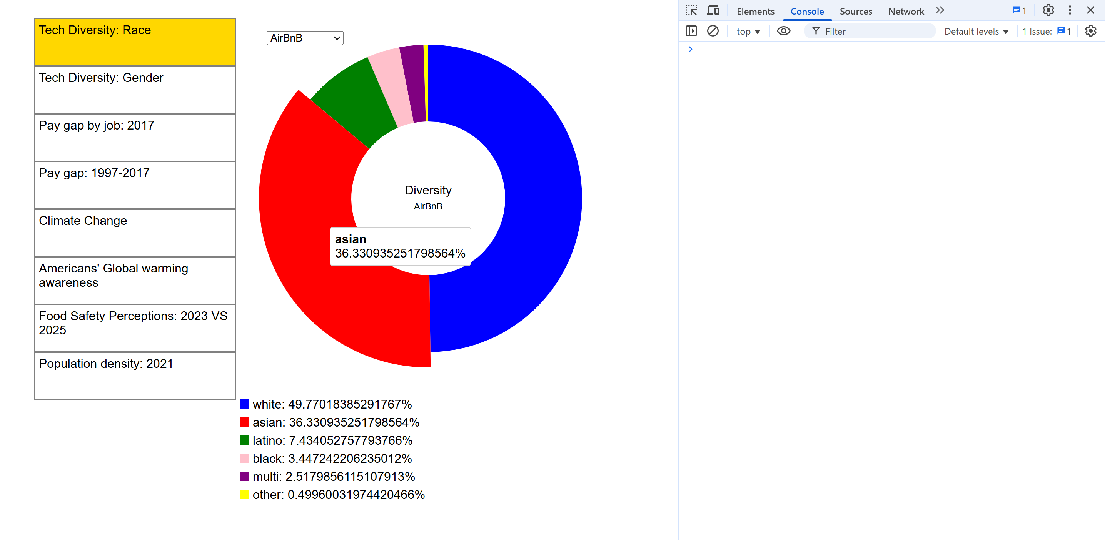
Pic 1: Company: AirBnB

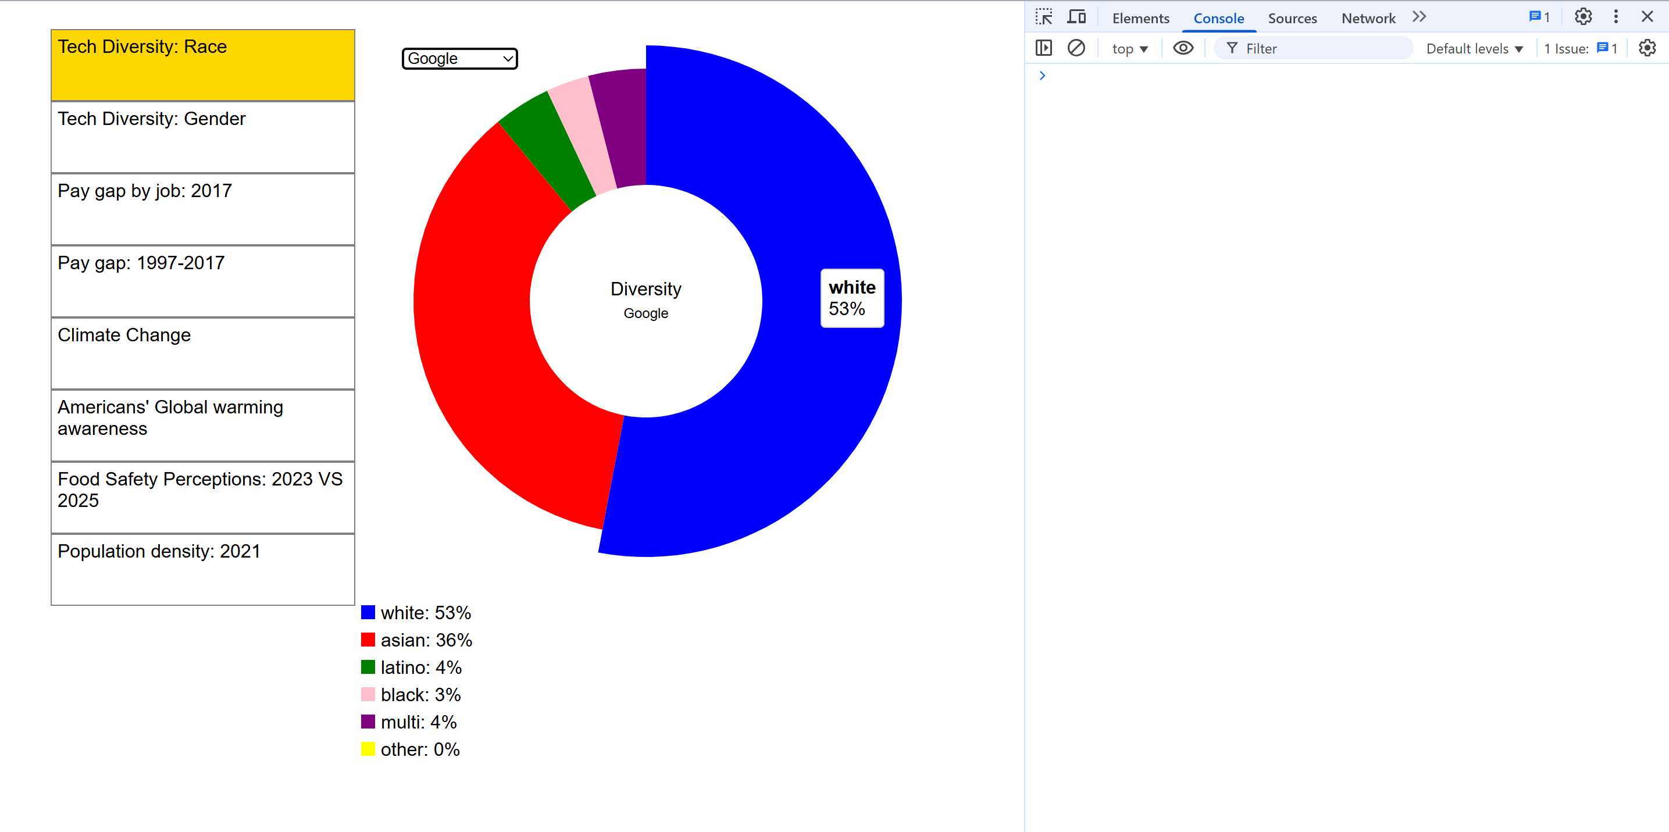
Pic 2: Company: Google

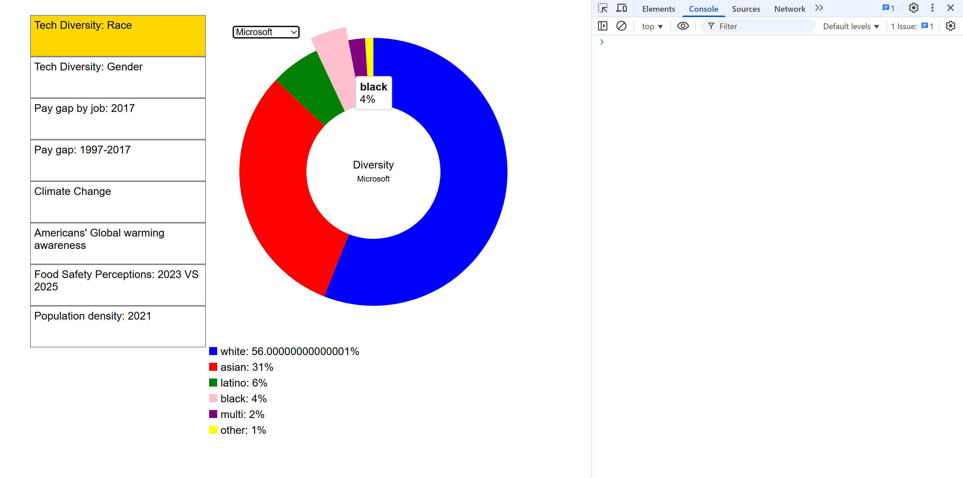
Pic 3: Company: Microsoft

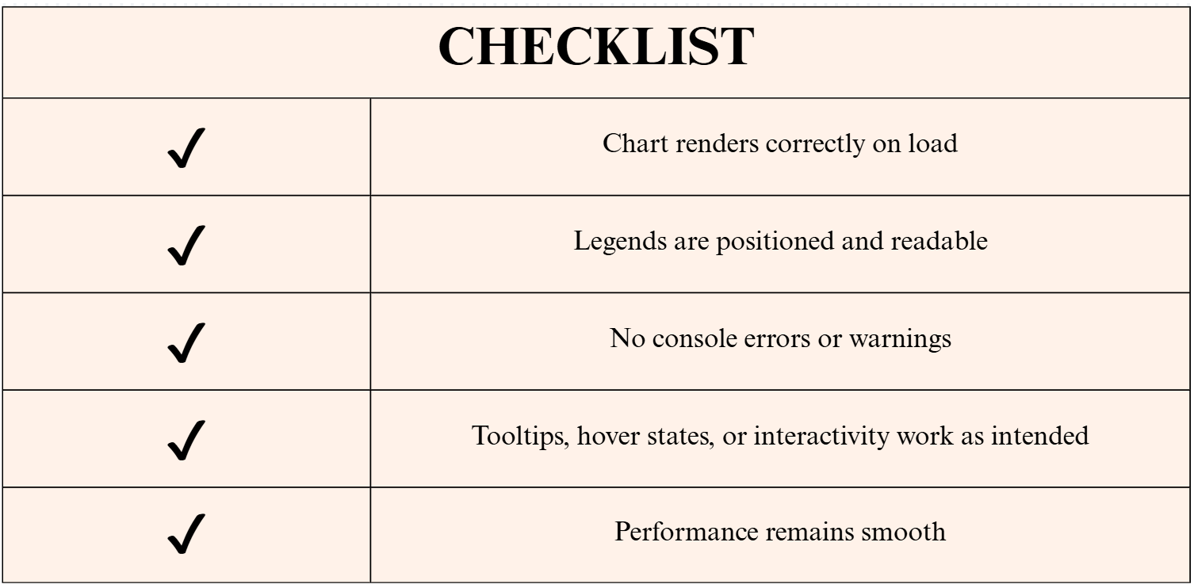

- Pay gap: 1997-2017
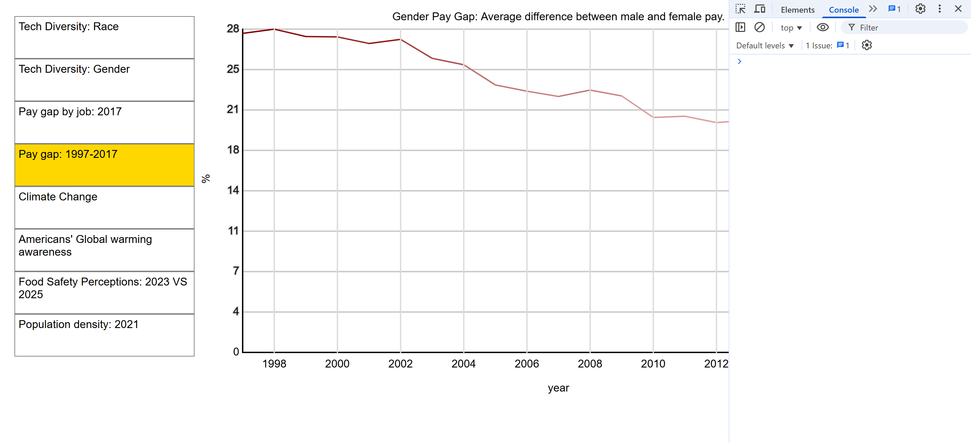
Pic 4: Colour intensity line graph

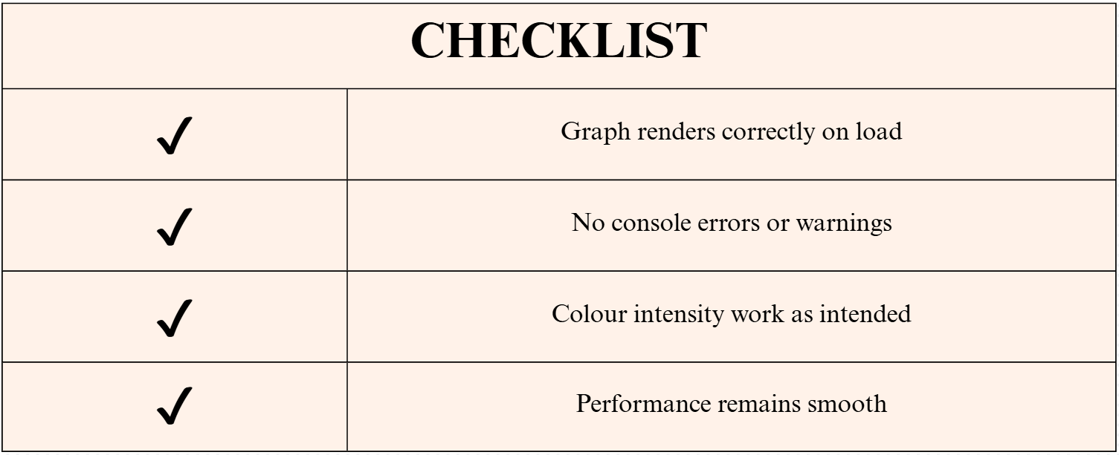

- American’s Global warming awareness
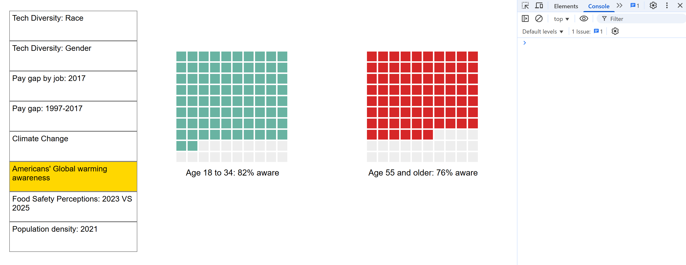
Pic 5: Waffle Charts

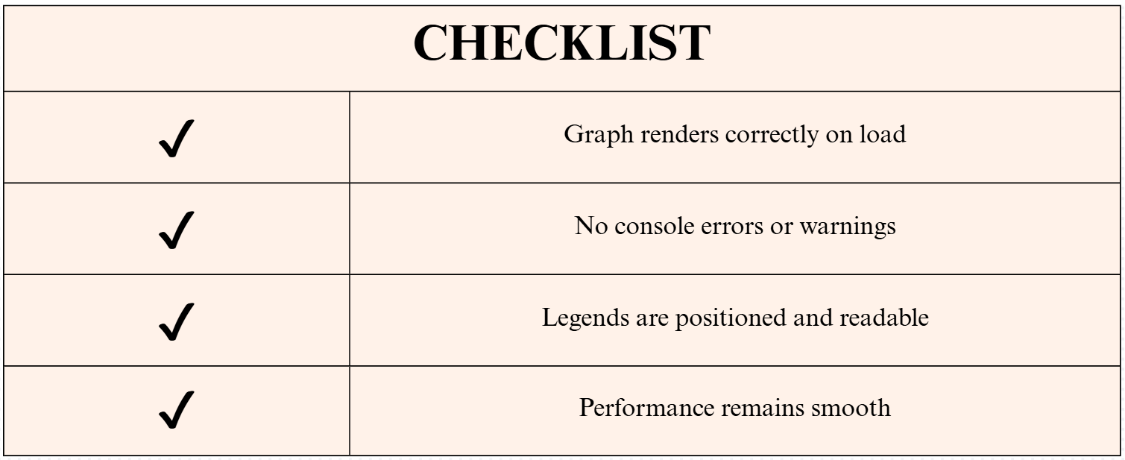

- Food Safety Perception: 2023 VS 2025
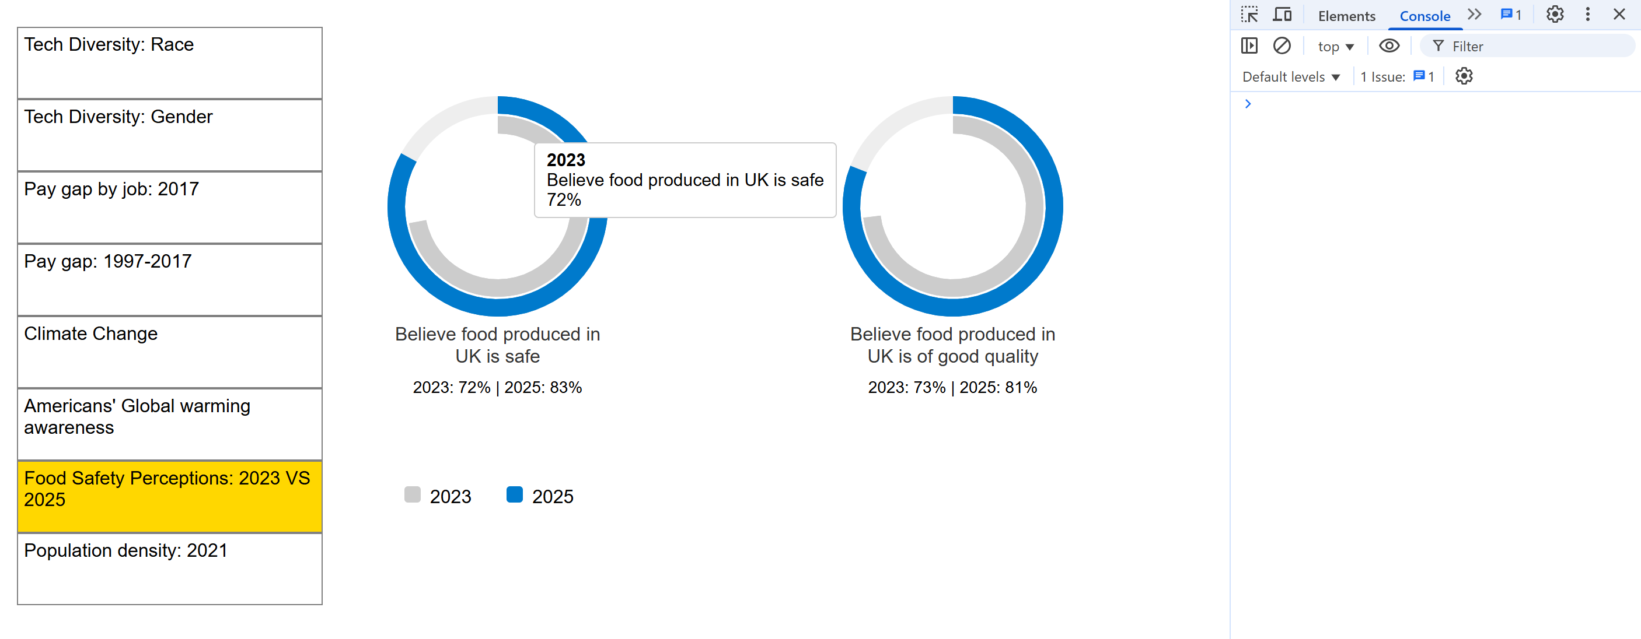
Pic 6: Circle Diagrams



- Population density: 2021
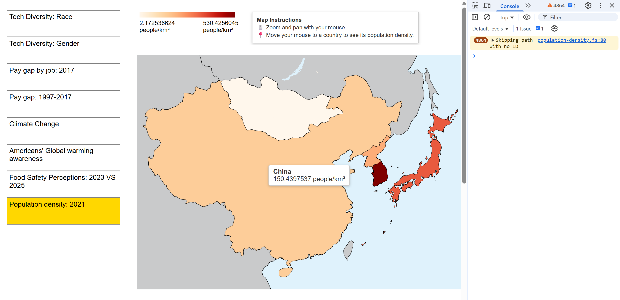
Pic 7: Heat Map

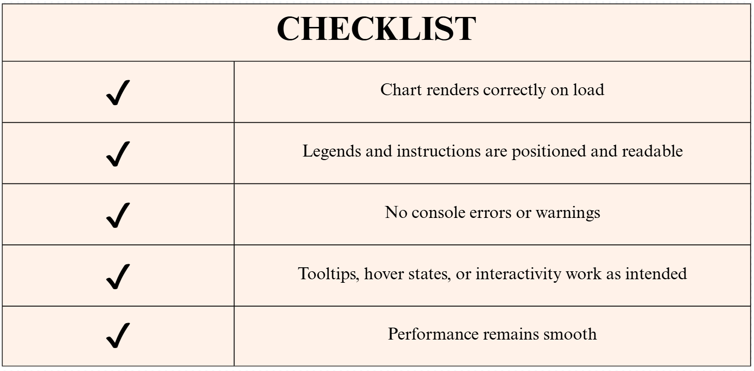

All extended data visualisations functioned as intended, with no errors detected.

I also conducted usability surveys with three participants using the System Usability Scale (SUS). Their responses provided valuable insights for the system’s overall usability and user experience.

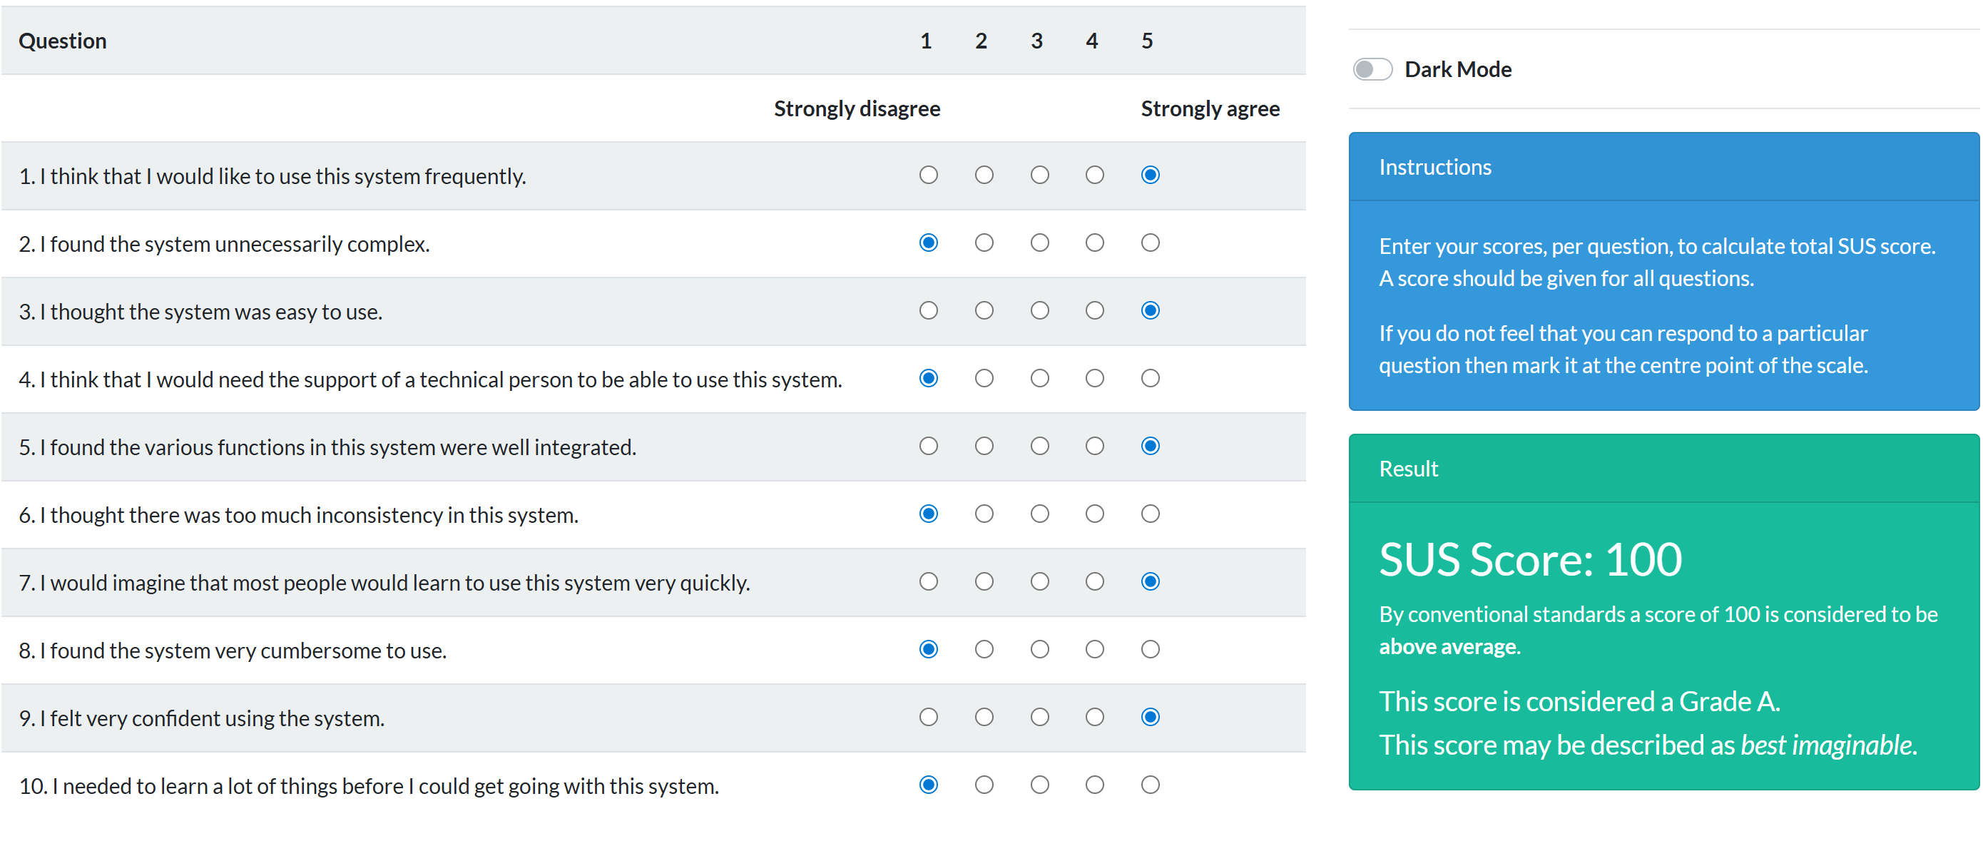
Pic 8: Response 1
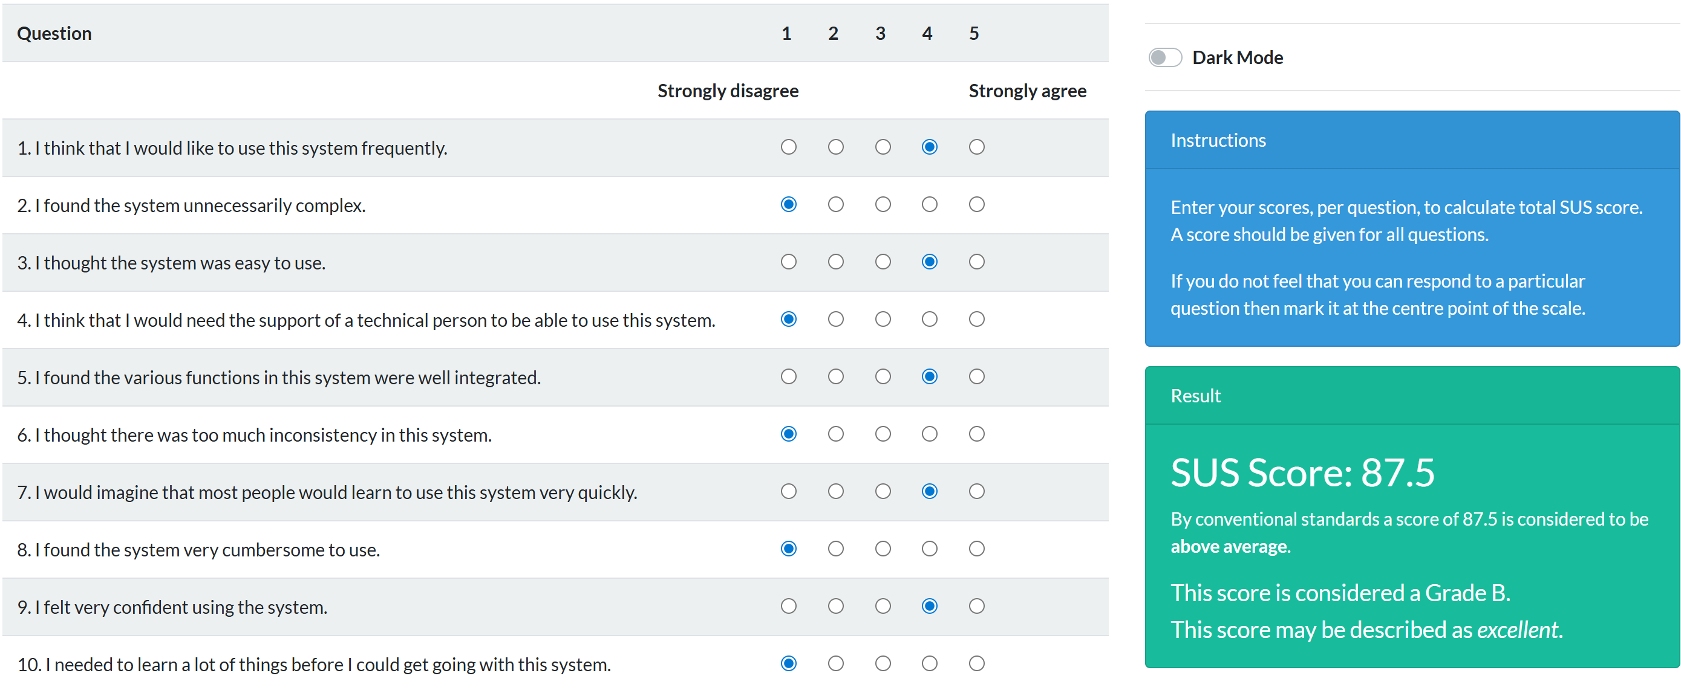
Pic 9: Response 2
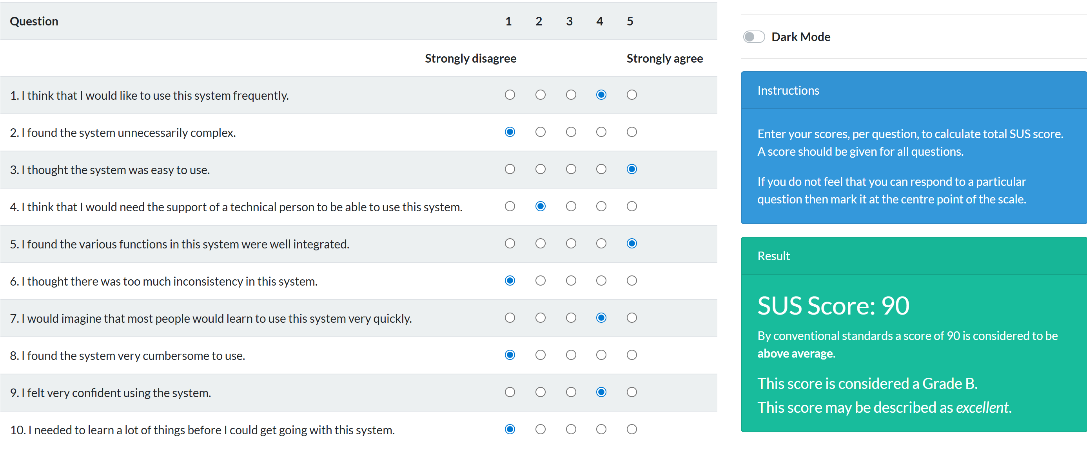
Pic 10: Response 3

All 3 responses had SUS scores above average, indicating a generally positive perception of the system’s usability. This suggests that the system is perceived as usable and well-designed by its target users.

What problems have you faced and were you able to solve them?
No critical issues were encountered. All extensions and feature enhancements were successfully integrated and validated through stability and usability testing.
What are you planning to do over the next few weeks?
In this final week, I’m consolidating my work, refining documentation, and ensuring all deliverables meet quality standards.
Are you on target to successfully complete your project? If you aren’t on target, how will you address the issue?
I am on target to successfully complete my project. Following a comprehensive round of stability, usability, and performance testing, all features have been validated and the final version is ready for submission.

